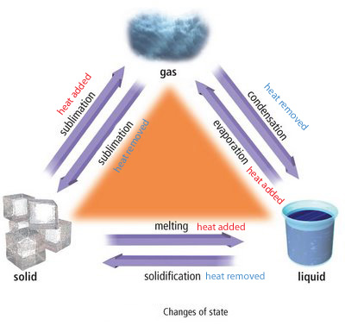

**Solidification = making solid (freezing)**